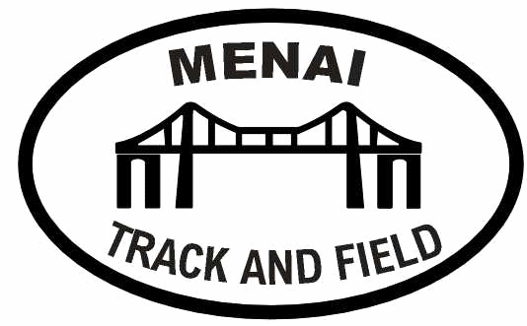
YNYS MON IGA & MENAI TRACK & FIELD OPEN MEETING
Under UKA Rules
at
TREBORTH ATHLETICS TRACK, BANGOR, LL57 2RQ
(License Number – NORTH R.A.C.TF-90)
Sunday 8th September 2019
(10am start)

(No Admission fee / No parking fee / Medals for 1st 2nd 3rd in all events)

 | 75m | 100m | 150m | 200m | 300m | 400m | 600m | 800m | 1 Mile | Steeplechase | 3000m | Sprint Hurdles | Long Jump | Triple Jump | High Jump | Javelin | Shot Put | Discus | Hammer
U11G
U11B
U13G |  |  |  |  |  |  |  |  |  |  |  | 70
U13B |  |  |  |  |  |  |  |  |  |  |  | 75
U15G |  |  |  |  |  |  |  |  |  |  |  | 75
U15B |  |  |  |  |  |  |  |  |  |  |  | 80
U17W |  |  |  |  |  |  |  |  |  |  |  | 80
U17M |  |  |  |  |  |  |  |  |  |  |  | 100
U20W |  |  |  |  |  |  |  |  |  |  |  | 100
U20M |  |  |  |  |  |  |  |  |  |  |  | 110
SENW/MWOM |  |  |  |  |  |  |  |  |  |  |  | 100
SENM/MMEN |  |  |  |  |  |  |  |  |  |  |  | 110
Entry fees: £5 per event or 3 events for £12
(ONLINE PAYMENTS VIA ONLINE ENTRIES)

Under 13’s cannot compete in 800m and 1 mile on the same day.

Under 15’s cannot compete in more than one of 800m, 1 mile, or 3000m on the same day.
Under 11’s / 13’s & U15’s cannot compete in more than three events.
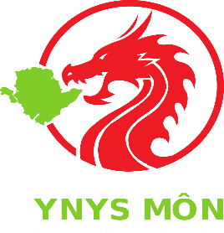

ONLINE ENTRIES ONLY – https://www.bespokeentries.co.uk/menai-open-2019

CLOSING DATE FOR ENTRIES – 01/09/19

