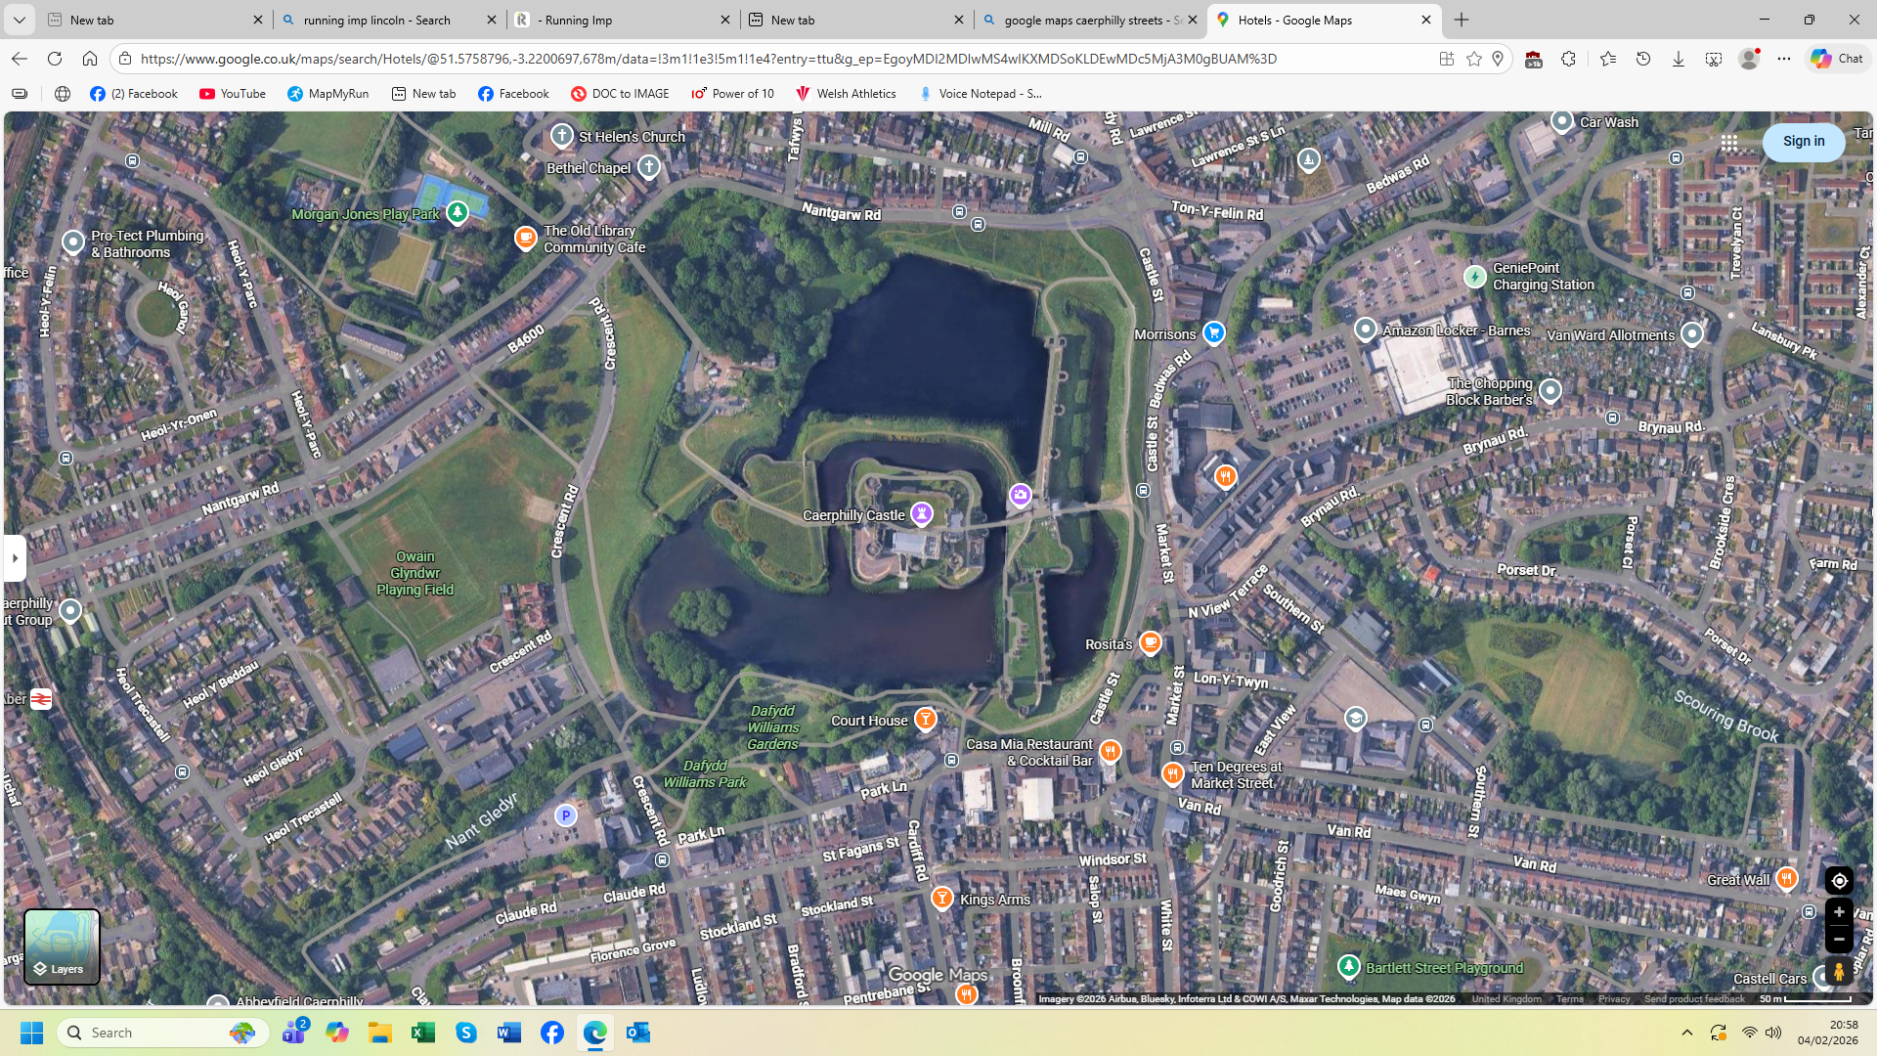

4K
3K
2K
1K
CARDIFF ROAD
PARK LANE
MARKET STREET
CASTLE STREET
CRESTEN ROAD
NANTGARW ROAD
CAREPHILLY 5K CLASSIC
The Start out side Rosita’s race HQ in Castle Street the course will run 3 laps around Caerphilly Castle and will finish in Market Street. All roads will be closed to traffic by Caerphilly traffic management team and they will marshal the course. The Course will run on Castle Street, Nantgarw Road, Crescent Road, Park Lane, Cardiff Road, (in Red) Market Street into the Finish (in Blue)
CAERPHILLY 5K CLASSIC 9TH AUGUST 2026
FINISH
START


ROSITA’S RACE HQ

